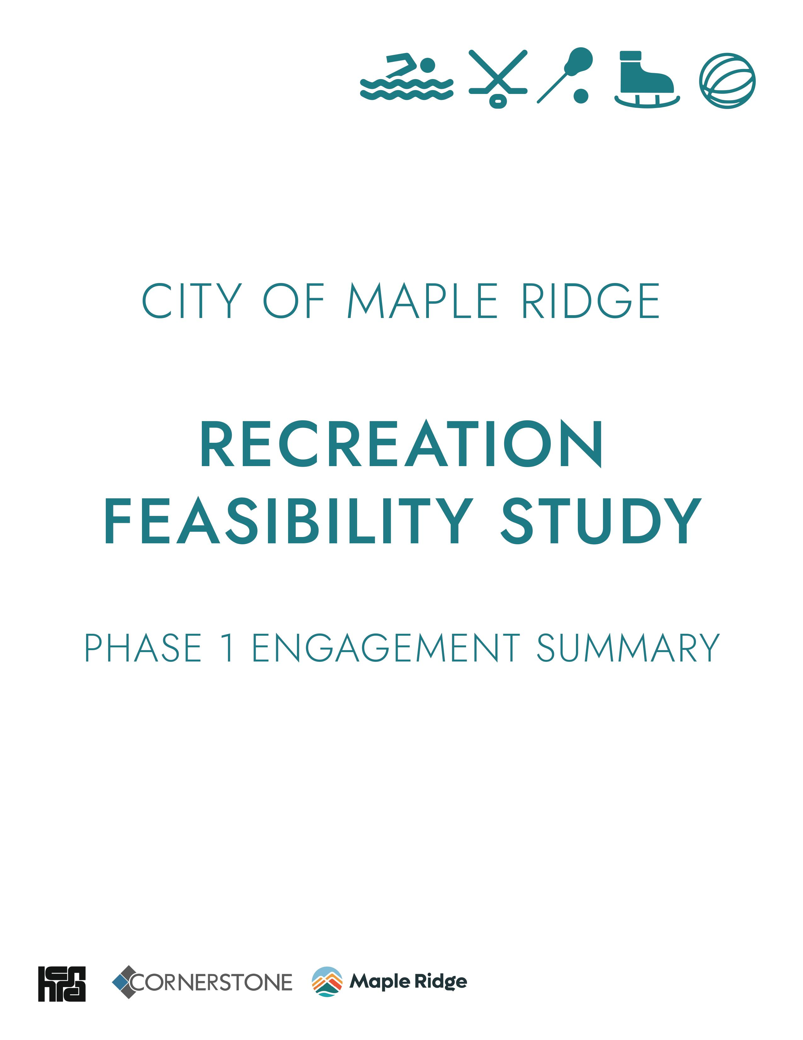

The City of Maple Ridge respectfully acknowledges that we are on the traditional territories of the Katzie (q̓ic̓əy̓) and Kwantlen (qʼʷa:n̓ƛʼən̓) First Nations

Table of Contents
EXECUTIVE SUMMARY 5
Engagement Quick facts 8
WHAT WE HEARD SUMMARY INFOGRAPHIC 9
1 Introduction 10
1.1 Project Context and Goals 10
1.2 Project Approach and Schedule 10
1.3 Community Engagement – Phase 1 Approach 12
1.4 Community Engagement Summary Report Structure 13
2 Community Engagement Outcomes 15
2.1 Future Aquatic Facility Preferences 15
2.2 Future Arena Facility Preferences 17
2.3 Other themes 19
2.4 Support for a New Recreation Centre 20
2.5 General recreation perspectives 21
3 Engagement Conclusions 22

EXECUTIVE SUMMARY
In January 2024, the City of Maple Ridge began an extensive engagement process to support and inform subsequent stages of the Recreation Feasibility Study. The Study focuses on the proposed development of a new multi-use recreational facility at Hammond Community Park.
The goal of the engagement process was to:
- gather insights on the community’s current use of recreation facilities, as well as any challenge; and
- obtain information on preferences and priorities for future program spaces and activities in the proposed recreation facility.
The robust engagement process adhered to the “consult” level of the International Association for Public Participation (IAP2) and included four key activities:
- Public Survey – focused on understanding the community’s current recreation use patterns and identifying how the City can improve recreation opportunities in the future. The public survey garnered 2,358 responses.
- Recreation and Community Organization User Group Surveys – focused on understanding how the organizations interact with recreation facilities and identifying their service challenges related to infrastructure. These surveys garnered 183 responses.
- Open Houses – a series of open houses were held at key locations, including Maple Ridge Public Library, Maple Ridge Leisure Centre, Planet Ice Arena, and a neighbours-only open house at Hammond Community Centre. The intent of the open houses was to increase Study awareness, capture sentiments related to current and future recreation use patterns and to identify project related concerns. The open houses drew hundreds of participants and resulted in over 600 captured sentiments.
- Stakeholder Interview Sessions – 17 community, rental-user group, and city department stakeholder sessions were held to understand program, service, and operational challenges and opportunities related to recreation infrastructure within the City.
Key engagement outcomes are summarized below and organized into four categories: aquatics, arenas, general recreation and other.

Aquatics   | According to public survey respondents:  - The current most popular aquatic activities are drop-in swimming (67% reporting regular participation), swim lessons (40% reporting regular participation) and aquatic amenity use (sauna, steam room and hot tub, 34% reporting regular participation).  - The most important activities to consider for a future aquatic facility, as reported by the community, are:  1. leisure and recreation activities  2. swim lessons, and  3. rehabilitation activities.  - The least important aquatic activity noted by respondents was competitive sport and training.  - 25% of respondents identified that a new recreation facility should consider the inclusion of an outdoor aquatic amenity.  - The community would like to see new aquatic infrastructure that includes features such as: hot tubs (69% of respondents) lazy rivers (62% of respondents), and waterslides (57% of respondents).  This feedback highlights the community's desire for a future aquatic facility that focuses on providing spaces to accommodate leisure and recreation, skill development and rehabilitation and therapy activities. It underscores the importance of prioritizing a leisure-oriented aquatic facility over a competitive sport-oriented facility.
Arenas | According to public survey respondents:  - The current most popular arena activities are public skating (51% reporting regular participation), ice hockey (32% reporting regular participation) and skating lessons (23% reporting regular participation).  - The most prominent challenge experienced by the community today is related to the insufficient supply of prime-time ice and dry floor access. Requests for increased access to ice was the third most prominent theme (230 responses) identified in the survey comment section.  - The most important activities to consider for a future arena facility, as reported by the community are:  1. skill development  2. competitive sports  3. community programming (drop-in and leisure programs).  - The community would like to see new arena infrastructure include an indoor walking track (surrounding the arena) and improved arena support areas (fitness spaces, changerooms, spectator seating, food options etc.).  This feedback suggests that community members are not only in need of an increased supply of ice and dry floor facilities but also improvements and enhancements to arena amenities that support leisure and recreational uses.
General Recreation   | In addition to aquatic and arena needs and preferences identified through the public survey, several other perspectives and desires regarding future recreational facilities were identified:  - There's a perceived shortage of City-operated fitness and training areas (indoor cardio and weightlifting). 31% of respondents indicated a new facility should include a fitness area.  - The community would like to see a new facility include indoor walking tracks (30% of respondents), a climbing wall (18% of respondents), children’s play spaces (17% of respondents) and youth focused spaces (17% of respondents).
Other Themes   | Although the purpose of the engagement was to understand priorities for future spaces and activities and not to ask for input on facility location, the results of the open-ended question provided some notable findings on this theme. Of the 2,358 survey respondents, 257 (10.9%) expressed concern about the loss of baseball diamonds as a result of site development, and 172 (7.3%) expressed direct opposition to the proposed location.  Similarly, the public survey and engagement process did not specifically ask whether there was support for a new recreation centre; however, a significant number of survey respondents (698, which accounts for 30% of all survey respondents) expressed their support and enthusiasm for a new recreation facility in Maple Ridge.
While the information presented above primarily originated from the public survey data, similar themes were observed in the open houses and stakeholder engagement sessions. The information collected in these more qualitative engagement activities paralleled the perspective that there is an acute shortage of aquatic, arena, and recreational amenities in the City of Maple Ridge.
How will this information be used in the next phase?
The outcomes of this engagement will directly inform the Service Demand Analysis which projects the current and long-term community recreation needs (program, service and infrastructure). The Service Demand Analysis is slated to be completed in April 2024. The findings of this Study will provide facility program recommendations that will then be used in the concept design (site test-fits) and project costing that are projected to take place between April-May 2024. In June 2024, the second stage of the public engagement process will take place, that will report out on the findings of this engagement and how it has informed the feasibility tudy. It will be used to verify what we have heard and obtain further feedback.

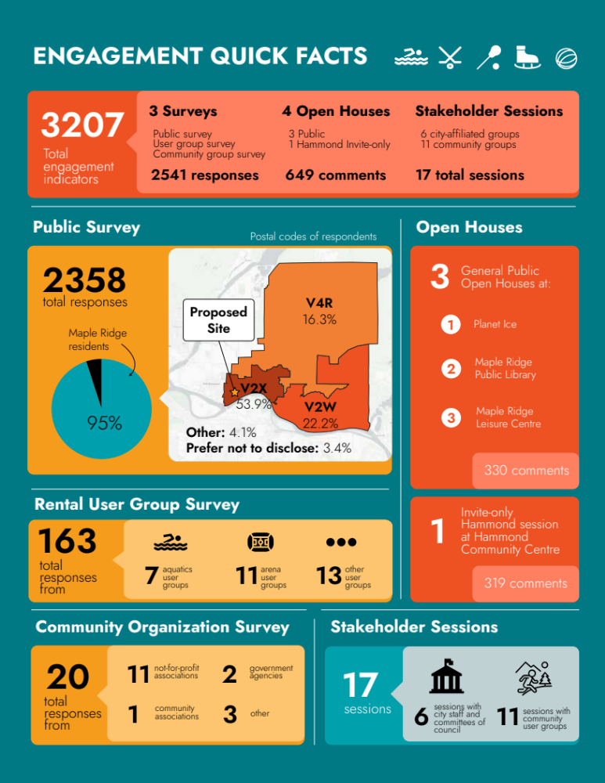
Engagement Quickfacts

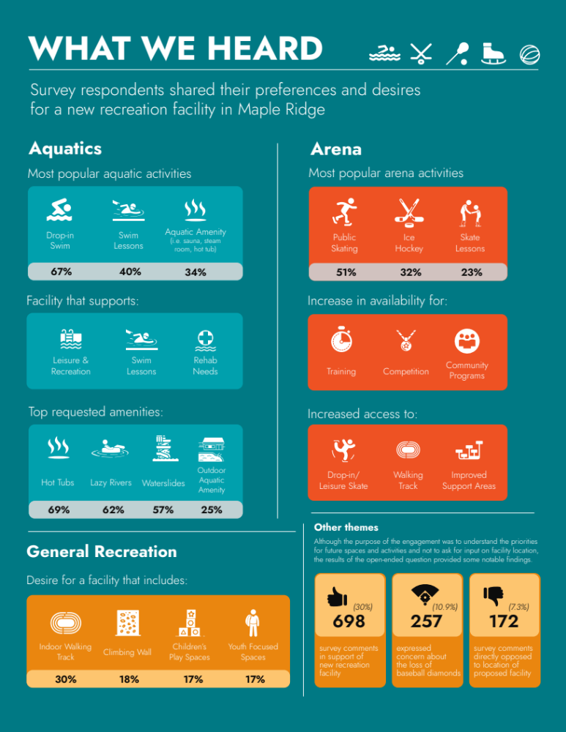
WHAT WE HEARD SUMMARY INFOGRAPHIC

Introduction

Project Context and Goals
The City of Maple Ridge (the City) has undertaken recent planning initiatives to understand the arts, culture and recreation needs and wants of the growing community. In the 2023 Parks, Recreation, and Culture Master Plan, the City identified a pressing need for new aquatic and arena facilities, ranking these among the top 5 recreation capital investment priorities. In response to these investment priorities, the City identified the need to complete a Recreation Feasibility Study which aims to:
- Assess the current state of recreation within the City with a focus on aquatic and arena services and infrastructure.
- Estimate the future demand of recreation with a focus on aquatic and arena services and infrastructure.
- Quantify the facility and site requirements to meet future demands.
- Assess the suitability of a preferred site location to support a new recreation centre.
- Explore site and facility conceptual design options at the preferred site location.
- Recommend the most beneficial path forward for the City.

City staff completed a site identification analysis and assessed several City-owned sites and privately-owned properties, ranked them against a set of selection criteria including overall site size, approximate land costs, potential servicing cost impacts proximity to areas of increasing population, and access to transit and a major transportation route. Hammond Community Park ranked the highest through the assessment and has therefore been put forth as the preferred site for assessment within the Recreation Feasibility Study.

Project Approach and Schedule
hcma architecture and design (hcma) in partnership with contracted specialty consultants has been contracted to complete the Feasibility Study. The approach to complete the Study has been organized into six key stages of work, detailed in Figure 1 below. Each stage is designed to build sequentially on the previous stage and inform the stage that comes after it.
Figure 1: Project Approach and Schedule
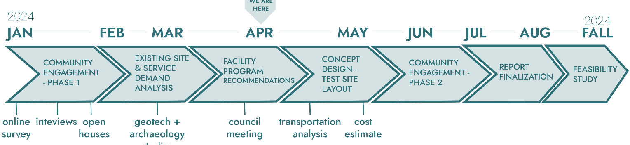
- Community Engagement – Phase 1 | This stage of work focuses on engagement with community, recreation and community organization user groups, and City staff to collect information and perspectives related to the current and future recreational programs, services and recreational needs of Maple Ridge. A variety of engagement was completed including, interviews, surveys, open houses and focus group sessions. A detailed overview and assessment of the engagement completed is provided within this report, Phase 1 Engagement Summary. This stage of work was led by Cornerstone Planning Group (Cornerstone).
- Existing Site and Service Demand Analysis | This stage of work includes several site and service demand assessments.  - Site geotechnical assessment – led by GeoPacific  - Site archaeological Study – led by Katzie Development Limited Partnership.  - Site transportation and parking analysis – led by Binnie Civil Engineering Consultants.  - Topographical Survey - led by Bennett Land Surveying  - Current state recreation service assessment – led by Cornerstone.  - Future recreation demand analysis – led by Cornerstone.  The outcome of this stage of work includes a detailed assessment of the proposed site and a summary of the current and future demand of recreation activities within the City.
- Facility Program Development | Using the outcomes of the future recreation demand analysis, a facility program is produced. The program provides an architectural roadmap for the types and sizes of spaces that are required in a new recreation centre to meet the projected demand of the community. The program will also identify the functional relationship between spaces and/or zones of use. Dependent on the outcomes of the demand analysis there may be the need to develop multiple facility programs.
- Concept Design – Test Site Layout | The concept design stage of work focuses on the development of possible facility and site layout scenarios. Concepts will be prepared at a building massing level and using the findings from the site assessments and facility program. This stage of work will include the preparation of Class D capital cost estimates.
- Community Engagement – Phase 2 | Phase 2 of engagement focuses on presenting back to the community and project stakeholders the key outcomes of the existing site and service demand analysis, facility program and concept design work. Engagement activities will include a public survey, open houses and focus group interview sessions. Following a similar approach to the Phase 1 engagement, the project team will prepare a Phase 2 Engagement Summary.
- Reporting | Final reporting will see the culmination of all previous project work into a single document, the Feasibility Study.
The project commenced in December 2023 and is anticipated to wrap up in the fall of 2024. This report offers a summary of the Phase 1 Community Engagement, which marks the initial stage of the Study. Further details on this process are provided below.

Community Engagement – Phase 1 Approach
The initiatives within the engagement plan were intended to provide residents with information and resources to participate in numerous engagement activities. These included survey and open house household post card distribution, newspaper ads, facility poster campaign, pop up banner displays, digital TV screen promotion at civic facilities, tent card and sign distribution to local businesses and transit shelter ads. In additional digital outreach included social media all-platform posts, three Mayor's videos, Facebook events and digital paid ads in the local newspaper. Several engagement activities have been completed as part of Phase 1 engagement.
A multi-faceted approach has been undertaken to promote broad public and stakeholder engagement. The following table summarizes the engagement activities completed.
Table 1: Phase 1 Engagement Activities
Activity | Details | Participation
Public Survey | Active Jan. 23 – Feb. 23, 2024 | 2,358 respondents
Recreation User Group Survey | Active Jan. 23 – Feb. 23, 2024 | 162 respondents
Community Organization User Group Survey | Active Jan. 23 – March 1, 2024 | 20 respondents
Open House – General Public | Public Library – Jan. 31, 2024  Leisure Centre - Feb. 11, 2024  Planet Ice – Feb. 15, 2024 | 330 comments captured
Open House – Hammond Community | Hammond Community Centre – Feb. 3, 2024 | 319 comments captured
Targeted Stakeholder Interviews and Workshops | Jan. – Feb. 2024  Participating Stakeholders included:  Participating Stakeholders included: Ridge Meadows Flames Junior Hockey, Maple Ridge Skating Club, Ridge Meadows Minor Hockey, Ridge Meadows Speed Skating, Rick Hansen Foundation, Ridge Meadows Child Development Centre, Maple Ridge Pitt Meadows Katzie Seniors Network, Haney Neptunes Aquatics Club, Ridge Meadows Swim Club, Ridge Meadows Minor Lacrosse, Burrards Senior Women’s Box Lacrosse, Fraser Valley Regional Library, Ridge Meadows Minor Baseball, Hammond Caretaker, School District 42 – Maple Ridge & Pitt Meadows, Meadowridge School, Racquetball BC, Squash BC, Golden Ears Pickleball, Aquafit Participant Champions, Maple Ridge Burrards, GSL Properties (Planet Ice), Local Immigration Partnership, Greg Moore Youth Centre participants | 11 sessions
Committee of Council Workshops | Dec. 2023 – Feb. 2024  Participating Stakeholders included:  Agricultural Advisory Committee, Public Art Steering Committee, Economic Development Advisory Committee, Transportation Advisory Committee, Environmental Advisory Committee, Parks, Recreation & Culture Advisory Committee, Social Policy Advisory Committee, Municipal Advisory Committee on Accessibility and Inclusiveness | 6 sessions

Community Engagement Summary Report Structure
This document, the Phase 1 Community Engagement Summary, has been structured to provide a concise overview of key information. The subsequent section outlines the organization of the report:
Main Body:
- Community Engagement Outcomes: Identifies predominant themes arising from diverse community engagement initiatives, encompassing public surveys, recreation user group surveys and interviews, community organization user group surveys and interviews, as well as open houses and stakeholder interviews with recreation-affiliated user groups.
- Conclusion: A summary of overarching themes derived from all engagement activities conducted in Phase 1.

Community Engagement Outcomes
Considerable efforts have been made to collect community feedback using several engagement tools and activities. This section summarizes the key themes and findings from the engagement process, which includes a blend of both quantitative and qualitative information. It aims to provide details regarding the community's overall support for the recreation facility, prominent concerns raised by the community, and what the community would like to see in a new recreation facility.

Future Aquatic Facility Preferences
 | Across all methods of engagement, including stakeholder interviews, survey data, and open houses, we heard that community members feel that the demand for aquatic facilities and programming in Maple Ridge surpasses the current supply. Community members also expressed concern about the shortage of City-led aquatic programming. Specifically, community members noted long waitlists for swim lessons and inadequate availability of drop-in swimming sessions.  The desire for enhanced access to both indoor and outdoor aquatic amenities, coupled with a call for more leisure-oriented features, was a recurring theme among community feedback. Respondents highlighted hot tubs, lazy rivers, and water slides as the three most sought after aquatic amenities. This reinforces the community's desire for leisure and recreation-focused facilities.  Results from the survey indicate that drop-in swimming was the most popular aquatic facility activity, with more than two-thirds of respondents reporting regular participation. Swim lessons and use of sauna, steam room, and hot tubs were reported as the second and third most popular aquatic activities with 40% and 34% of respondents reporting regular participation respectively. Survey respondents were also asked to rank a list of aquatic activities in order of importance, with 1 being the most important and 6 being the least important. Survey respondents ranked the activities as follows:  - Leisure and recreational swimming  - Skill development  - Rehabilitation and therapy  - Personal fitness  - Socializing  - Competitive sport/training  These results can be visualized as follows:  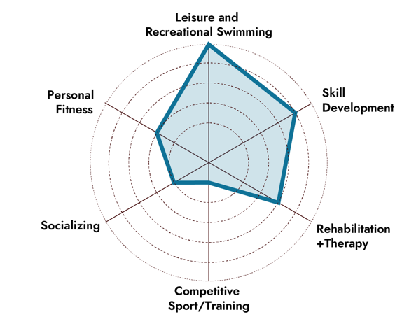  These results from the survey are consistent with the opinions expressed during interviews and open houses with stakeholders. It confirms that the community prefers aquatic facilities that provide leisure activities, recreation, and opportunities for skill development. This emphasizes the importance of including leisure-oriented amenities in a future facility. Although some stakeholders suggested having a competition-oriented pool, there wasn't a strong demand for a 50-meter pool. In fact, competitive sport/training was ranked as the least important activity by survey respondents. This underscores the importance of prioritizing a leisure-oriented aquatic facility over a competitive sport-oriented facility.
  Most Popular Activity, as selected by survey respondents:
  1. Drop In Swim – 67% of respondents reported regular participation
  2. Swim Lessons – 40% of respondents reported regular participation
  3. Sauna, steam room and hot tub – 34% of respondents reported regular participation
  Most Important Activities, as ranked by survey respondents:
  1. Leisure and recreation swims
  2. Skill development (swim lessons)
  3. Rehabilitation and therapy
  Top Requested Amenities, as selected by survey respondents:
  1. Hot tubs – 69% of respondents requested increased access to hot tubs
  2. Lazy rivers – 62% of respondents requested increased access to lazy rivers
  3. Waterslides– 57% of respondents requested increased access to waterslides
  4. 25% of respondents identified that a new recreation facility should consider the inclusion of an outdoor aquatic amenity.

Future Arena Facility Preferences
Most Popular Activity, as per selected by survey respondents
1. Public skating– 51% of respondents reported regular participation
2. Hockey – 32% of respondents reported regular participation
3. Skate lessons –23% of respondents reported regular participation
Most Important Activities, as ranked by survey respondents:
1. Drop-in and leisure skating
2. Walking track around arena
3. Improved support spaces

Similarly to the aquatic infrastructure, community perspectives suggest that the demand for arena infrastructure and programming in Maple Ridge surpasses the current supply. A prevalent theme was the significant limitation of ice availability, especially during peak usage times. Increased access to more ice time was the third most prominent theme identified in the open-ended comment section of the survey. Less frequently, but still a recurring theme, were demands for more dry floor options.
Community ice programming, encompassing public skating, stick and puck, and learn-to-skate sessions, face considerable demand that exceeds the City's capacity, primarily due to competing demands from sports user groups and the restricted availability of ice sheets. Many ice and dry floor sport user groups have reported a consistent year-over-year increase in participation, further exacerbating the challenge of meeting demand. Community perspectives indicate there is a need for multiple arenas, highlighting the benefits of twin-sheet layouts over single sheets.
Results from the survey indicate that more than half of survey respondents indicated frequent visits to Maple Ridge's arenas as ice users and 28% reported frequent visits as dry floor users. Public skating emerged as the most popular arena activity, with 51% of respondents reporting regular participation. Hockey and skate lessons closely followed, with 32% and 23% of respondents, respectively, reporting regular participation.
Survey respondents were asked to rank a list of arena priorities in order of importance, with 1 being the most important and 7 being the least important. Survey respondents ranked the priorities as follows:
- More drop-in and leisure skating
- Walking track around arenas
- Improve support areas in arena
- Increase group rental ice time
- Increase drop-in dry floor time
- Increase group rental dry floor time
- Introduce inclusive programming
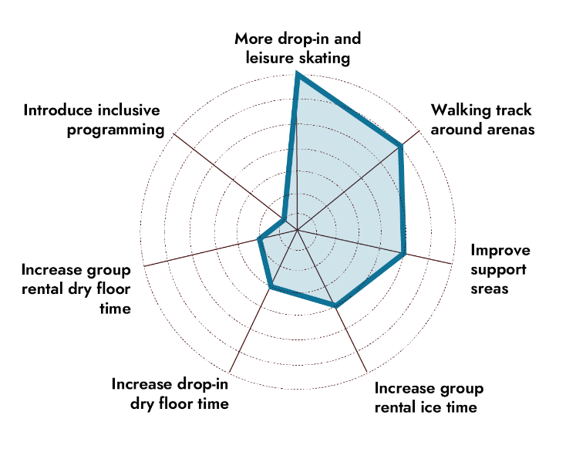
These results can be visualized as follows:
These results emphasize a clear desire for leisure arena spaces and programming within the community. This suggests that community members are not only in need of an expanded supply of ice and dry floor facilities but also improvements and enhancements to arena amenities and support spaces. In response to these community perspectives, a future recreation facility should incorporate additional spaces such as walking tracks, fitness areas, and flexible event spaces to enhance community enjoyment and wellbeing.

Other themes
Although the public survey and engagement process did not specifically target capturing proposed location concerns, notable findings emerged:
- 257 survey comments were received that expressed concern associated with the loss of the baseball diamonds, of which 59% originated from the V2X postal code in west Maple Ridge, where the site is located.
- 172 survey comments were received in opposition to the proposed site, with 87% submitted by residents of the V2X postal code in west Maple Ridge, where the site is located.
- Additionally, concerns related to parking and traffic were raised by 63 (2.6% of survey respondents) and 58 (2.5% of survey respondents) respectively, with 93% and 73% of these originating from the V2X postal code in west Maple Ridge, where the site is located.
The following concerns emerged specifically from the Hammond Community Open house (represented by 132 attendees):
- Some neighbours felt a large institutional building would not align with the look and feel of predominantly single-family residences in the neighbourhood. Some residents favoured improving existing infrastructure to maintain alignment with the neighbourhood character.
- Some residents felt excluded from the city's planning process for a new recreation center and would have preferred a forum-style format for voicing concerns.
- Residents have a strong connection to Larry Walker's legacy and the relationship between Hammond Community and baseball. Some have concerns about the city's commitment to replace the current baseball fields.

Support for a New Recreation Centre
 | One of the key themes emerging from the public engagement process was the notable level of support for the development of a new recreation facility in Maple Ridge. Support or excitement for a new facility was the top received comment in the open-ended comment section of the survey.  Generally, participants indicated that the city was overdue for new recreation facilities, noting that as the city has continued to grow, recreation amenities had not kept pace with the expanding population.  This sentiment was echoed in specific requests for amenities, such as increased arena space for ice and dry floor activities, expanded aquatic facilities with a focus on leisure amenities, increased fitness and general recreation spaces and increased provision of multipurpose and outdoor recreation spaces.  Specifically, 698 survey comments were received in support of a new recreation facility. Of these, 50% originated from the V2X postal code. Furthermore, 39 (1.6%) comments expressed support for Hammond Community Park as the selected site, with 87% from residents within the V2X postal code area.

General recreation perspectives
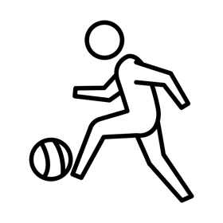 | In addition to aquatic and arena needs and preferences identified through the public survey, several other perspectives and desires regarding future recreational facilities were identified:  - There's a perceived shortage of City-operated fitness and training areas (indoor cardio and weightlifting). 31% of respondents indicated a new facility should include a fitness area.  - The community would like to see a new facility include indoor walking tracks (30% of respondents), climbing wall (18% of respondents), children’s play spaces (17% of respondents) and youth focused spaces (17% of respondents).

Engagement Conclusions
Phase 1 of community engagement in support of the Recreation Feasibility Study included several engagement activities aimed at capturing perspectives, needs, desires and considerations that will inform later stages of analysis. The following engagement snapshot summarizes the engagement completed between January 2024 and March 2024.
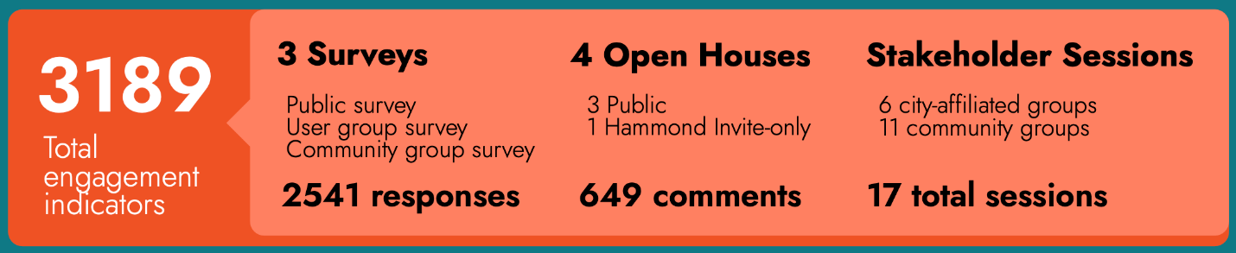
Following the assessment of the engagement results, several conclusions can be made. They are:
- There is acknowledgment throughout the community that there is an existing shortage of recreation and community spaces to support the current population. Demand will continue to increase as the City grows and the gap in provision of recreation and community spaces will further increase. The community identified a wide range of recreation and community space needs for a new facility.
- Overall, the results indicate a clear need for more aquatic, arena, and recreation facilities that prioritize recreation, leisure, and rehabilitation and therapy and should be welcoming and accessible to the entire community.
- Notable support and excitement for a new recreation facility in Maple Ridge was identified, with 30% of all survey respondents indicating their enthusiasm in the open-ended comment section of the survey. This constituted the top received comment in the open-ended comment section of the survey. Of these, 50% originated from the V2X postal code area where the site is located. Furthermore, 39 (1.6%) comments expressed support for Hammond Community Park as the selected site, with 87% of the 1.6% originating from residents within the V2X postal code area.
- The community and project stakeholders identified the desire and project need for meaningful engagement with local first nations.
The findings of the Phase 1 Engagement will be presented to Council in April 2024 and will be used to inform the Service Demand Analysis. The Service Demand Analysis is slated to be completed in April 2024. Facility program recommendations, site assessments, concept design and project costing are projected to take place between April-May 2024. A secondary public engagement process, aimed to present the findings of the analysis’, verify what we have heard and obtain feedback on our findings is projected to take place in June 2024.

