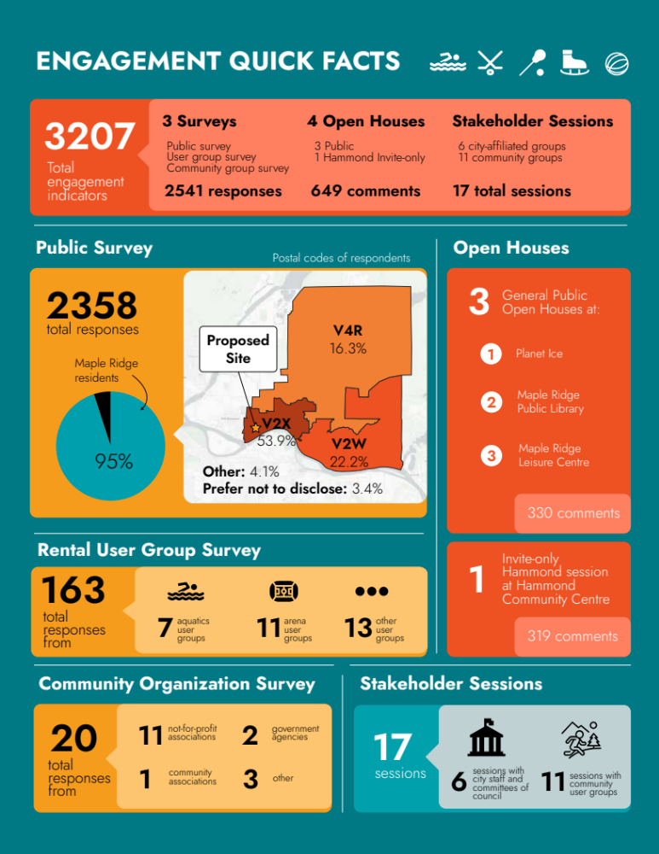
Engagement Engagement Quickfacts

